MED D - Test Claim - Calculating Quantity of Insulin Vials

Definition | Insulin dispensed in vials is a medication that is usually injected with a syringe. Medication is carefully drawn out of an insulin vial and into a syringe. Tiny gradation markers in the syringe aid in measuring the insulin dose. Typically, insulin vials contain 10 mL of insulin at a concentration of 100 units/mL.  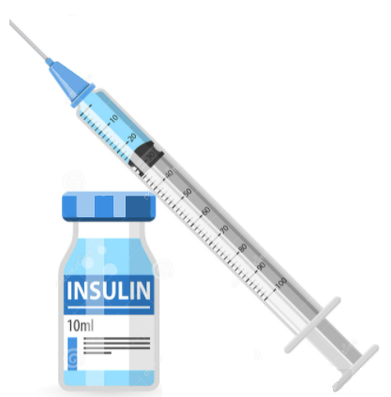
Instructions for Running a Test Claim | How many units does the beneficiary use each day?  What day-supply is needed?  How many packages are needed for the day supply prescribed?  Note: If you are unsure what quantity is needed consult with Clinical Care Services.
Common Direction (SIG) Codes | b.i.d. - 2x/day  t.i.d. - 3x/day  q.i.d. - 4x/day  ad - up to  p.r.n. - as needed  qd - every day  qh - every hour  q4h - every 4 hours  q.o.d. - every other day
Additional Notes | - Generally, each bottle of insulin expires 28 days from the date it is first used; therefore, a minimum of 3 bottles for an 84 day supply would be dispensed.  - Refer to the Quick Reference Guide for assistance with Test Claim quantity.
What if Test Claim Rejects | Review the rejection code to determine what caused the rejection. Once the rejection code is identified, access the proper work instruction and job aids in theSource to help you resolve the issue.

Example
NovoLog vials

Directions: 43 units in the morning and 26 units at night
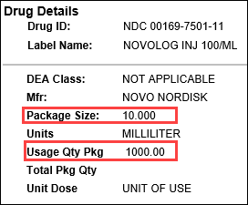 |  |  | 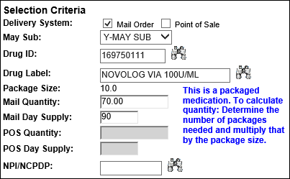
Calculation
Units per Day | X | Days |  | = | Units Needed
69  (43 + 26) | X | 90 |  | = | 6210
Units Needed | ÷ | Usage Quantity Package  (from PeopleSafe) |  | = | Total Number of Vials
6210 | ÷ | 1000 |  | = | 6.2 (Round up to 7)
Total Number of Vials | X | Package Size  (from PeopleSafe) |  | = | Test Claim Quantity
7 | X | 10 |  | = | 70

Example
Novolin R Vial

The caller states they need 4 packages/boxes for 90 days

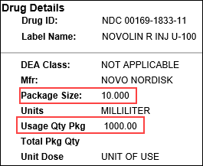 |  |  | 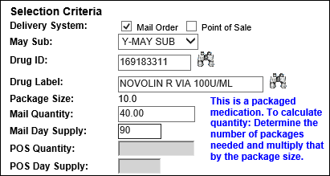
Calculation
Total Number of Packages | X | Package Size  (from PeopleSafe) |  | = | Test Claim Quantity
4 | X | 10 |  | = | 40

Top of the Document

Quick Reference Guide

Refer to the following tables for a quick reference:
30 Day Supply Quantities for Insulin Vials
How many units per day | Qty (ml) to enter in PeopleSafe) | Bottles Needed
1-11 | 10 | 1
12-22 | 10 | 1
23-33 | 10 | 1
34-44 | 20 | 2
45-55 | 20 | 2
56-66 | 20 | 2
67-77 | 30 | 3
78-88 | 30 | 3
89-100 | 30 | 3
101-111 | 40 | 4
112-123 | 40 | 4
124-134 | 40 | 4

90 Day Supply Quantities for Insulin Vials
How many units per day | Qty (ml) to enter in PeopleSafe) | Bottles Needed
1-11 | 30* | 3
12-22 | 30* | 3
23-33 | 30* | 3
34-44 | 40 | 4
45-55 | 50 | 5
56-66 | 60 | 6
67-77 | 70 | 7
78-88 | 80 | 8
89-100 | 90 | 9
101-111 | 100 | 10
112-123 | 110 | 11
124-134 | 120 | 12

*Generally, each bottle of insulin expires 28 days from the date it is first used; therefore, a minimum of 3 bottles for an 84 day supply would be dispensed.

Top of the Document

Related Documents
MED D - Test Claim Index
Calculating Quantities for Packaged Medication

Parent SOP: CALL-0049: Customer Care Internal and External Call Handling
Abbreviations / Definitions: Customer Care Abbreviations, Definitions, and Terms

Top of the Document

Not To Be Reproduced Or Disclosed to Others Without Prior Written Approval
ELECTRONIC DATA = OFFICIAL VERSION – PAPER COPY – INFORMATIONAL ONLY

